WD2 abundance indices

Currently used: SNS

The SNS is a coastal survey

Four survey series catching turbot are available: the Beam Trawl Survey (BTS; with two research vessels: ISIS and Tridens), the Sole Net Survey (SNS), and the Interna-tional Bottom-trawl Survey (IBTS) (Figures 2.6.6 and 2.6.7).

The IBTS catches very little turbot because the gear is designed to catch roundfish rather than flatfish. Hence, the IBTS was not further evaluated for use in an age-based assessment.

The BTS index uses a beam trawl to catch demersal species. The index is based on the catch in one of the two nets.

The BTS-ISIS index is based on catches between 52 and 239 individuals per year (Table 2.6.4). The number of individuals used to generate an age–length key can be larger than the number of individuals used for the index, because the index is based on only the catch in one of the two nets, while age samples can be taken from both nets.

The BTS Tridens caught between one and 16 individuals per year to base a potential index on. This is too low a sample to give an accurate age-structured index to be used in an age-based assessment. However, the overall index indicates a positive trend, but high interannual variation.

The procedure to create an age structured index series from the BTS-ISIS was updated prior to the working group. Previously, each individual fish caught was linked to an age–length key based on its length. The age–length key was based on all age samples in the BTS survey since 1991. The updated procedure first links the individual fish from which otoliths are taken to the length sample. This allows direct ageing of the fish in the cpue. Those fish for which no direct age sample is available are then assigned to ages using the age–length key based on all fish in the period 1991–2011.

The overall index time-series for the BTS-ISIS and SNS is given in Figure 2.6.8. The age structured BTS index is given in Table 2.6.5 and Figure 2.6.9 and the age structured SNS index is given in Table 2.6.6 and

The IBTS does not have age samples associated with it. These series can be calculated starting from the CPUE per length per haul in DATRAS. First, a selection is made for the round fish areas in the North Sea (expressed in numbers per hour). The index series in terms of numbers per hour is calculated by taking the average CPUE per length per ICES statistical rectangle. These CPUE per length per ICES statistical rectangle are used to calculate the CPUE per length per roundfish areas. The final index is the average of the CPUE per length per roundfish areas, summed over the lengths.

The IBTS index can also be expressed as a biomass per hour by multiplying the numbers per hour by the expected weight at length. The expected weight is calculated from the lengths by using a length weight relationship W= aL^b. Parameters a and b (0.0044, 3.3862) are taken from Coull et al (1989). The remaining index calculations for the weight based CPUE (kg/hr) are equal to the index based on the numbers per hour.

Finally, an exploitable biomass index time series can be calculated for the IBTS, equal to the procedure for the weight based index, but including only individuals > 30 cm.

The procedure used to calculate the (age aggregated) IBTS indices can also be used for calculating the BTS indices for the BTS-ISIS, BTS-TRIDENS, BTS-SOLEA and the UK-BTS. However, the BTS-ISIS data in the DATRAS dataset prior to 1998 is incorrect, and these series are only presented from 1999 onwards.

Tables

Table 1 SNS number of specimens in ALK, per age and in total. Note that the ALK that can be used comes from multiple surveys

0 1 2 3 4 5 6 7 8 Total

2004 0 30 4 1 1 0 1 0 1 38

2005 0 6 19 1 0 0 0 0 0 26

2006 0 31 4 1 1 1 0 0 0 38

2007 0 23 5 0 0 0 0 0 0 28

2008 3 17 16 5 2 1 0 2 0 46

2009 0 12 3 0 3 0 0 0 0 18

2011 0 25 2 0 0 0 0 0 0 27

2012 0 11 7 0 0 0 0 0 0 18

2013 0 14 2 1 0 0 0 0 0 17

2014 2 26 4 2 1 1 0 0 0 36

2016 0 9 25 7 1 0 0 0 0 42

Table 2 Turbot SNS estimated number of individuals per haul

Est. # individuals per haul Total Total

#indvs hauls

0 1 2 3 4 5 6 7 8 10 33 56

1975 47 11 9 1 0 1 0 0 0 0 0 0 37 69

1976 50 11 3 1 0 0 0 0 0 0 0 0 20 65

1977 43 10 4 9 3 2 2 0 1 0 1 0 120 75

1978 53 14 8 5 1 1 0 0 0 0 0 0 54 82

1979 55 13 10 3 0 0 0 0 0 0 0 0 42 81

1980 46 14 3 1 0 0 1 0 0 0 0 0 29 65

1981 52 13 3 2 0 0 0 0 0 0 0 0 25 70

1982 57 15 1 2 0 1 0 0 0 0 0 0 28 76

1983 46 10 8 5 5 1 0 0 0 0 0 0 66 75

1984 50 17 9 2 1 1 0 1 0 0 0 0 57 81

1985 53 15 5 3 0 0 0 0 0 0 0 0 34 76

1986 69 10 1 1 0 0 0 0 0 0 0 0 15 81

1987 68 10 0 0 1 0 0 0 0 0 0 0 14 79

1989 50 15 5 1 2 1 0 0 0 0 0 0 41 74

1990 40 11 11 3 1 1 0 0 0 1 0 0 61 68

1991 36 12 3 1 0 1 0 0 0 0 0 0 26 53

1992 37 9 5 2 0 1 0 0 0 0 0 1 86 55

1993 25 12 7 2 3 0 1 0 0 0 0 0 50 50

1994 52 16 6 1 2 1 0 0 0 0 0 0 44 78

1995 37 7 4 4 3 0 1 0 0 0 0 0 45 56

1996 43 8 3 2 1 0 0 0 0 0 0 0 24 57

1997 45 7 2 1 0 0 0 0 0 0 0 0 14 55

1998 44 9 3 1 0 0 0 0 0 0 0 0 18 57

1999 38 7 3 3 3 3 0 0 0 0 0 0 49 57

2000 37 10 4 3 0 0 1 0 0 0 0 0 33 55

2001 34 7 3 0 0 0 0 0 0 0 0 0 13 44

2002 33 9 4 2 0 1 0 0 0 0 0 0 28 49

2004 32 8 2 2 1 1 0 0 0 0 0 0 27 46

2005 32 12 4 1 2 0 0 0 0 0 0 0 31 51

2006 25 16 8 0 2 0 0 0 0 0 0 0 40 51

2007 30 8 3 1 0 0 0 0 0 0 0 0 17 42

2008 34 11 5 0 0 1 0 0 0 0 0 0 26 51

2009 42 9 0 0 0 0 0 0 0 0 0 0 9 51

2010 35 9 6 0 0 0 0 0 0 0 0 0 21 50

2011 31 7 4 0 0 1 0 0 0 0 0 0 20 43

2012 40 8 0 1 0 0 0 0 0 0 0 0 11 49

2013 36 12 1 1 0 1 0 0 0 0 0 0 22 51

2014 38 8 3 1 0 0 0 0 0 0 0 0 17 50

2015 31 5 11 2 2 0 0 0 0 0 0 0 41 51

2016 35 8 5 2 0 0 0 0 0 0 0 0 24 50

Table of number of ages in ALK, and totals

0 1 2 3 4 5 6 7 8 9 10 11 12 14 15 Total

1991 0 36 120 17 1 3 0 1 0 0 0 0 0 0 0 178

1992 0 51 65 22 2 2 0 0 0 0 0 0 0 0 0 142

1993 0 70 71 15 6 2 0 2 0 0 0 0 0 1 0 167

1994 0 68 88 9 3 0 0 0 1 0 0 0 0 0 0 169

1995 0 74 50 11 2 0 1 0 0 0 0 0 0 0 0 138

1996 0 26 124 9 4 1 1 1 0 0 0 0 0 0 0 166

1997 0 30 77 27 4 1 0 0 0 1 0 1 0 0 0 141

1998 0 72 47 12 12 0 0 0 1 0 0 0 0 0 0 144

1999 0 59 67 12 7 1 1 2 0 0 0 0 0 0 0 149

2000 0 96 49 28 8 3 3 0 1 0 0 0 0 0 0 188

2001 0 32 85 10 16 0 0 2 0 1 0 0 0 0 0 146

2002 0 72 33 11 3 1 1 0 1 0 0 0 0 0 0 122

2003 1 86 88 9 7 0 3 1 1 0 0 0 0 0 0 196

2004 4 95 55 26 0 8 4 0 1 1 0 0 0 0 0 194

2005 0 41 62 27 6 5 2 1 0 0 0 0 0 0 0 144

2006 0 51 47 17 4 1 0 0 0 0 0 0 0 0 0 120

2007 0 38 61 38 22 7 5 0 0 0 0 0 0 0 0 171

2008 0 41 66 31 10 7 2 4 1 0 0 0 0 0 0 162

2009 0 28 22 30 22 13 5 0 1 0 0 0 0 0 0 121

2010 1 48 35 11 7 6 3 2 0 1 0 0 0 0 0 114

2011 0 63 67 12 3 11 3 2 2 1 2 1 0 0 0 167

2012 0 23 89 47 22 6 7 7 2 2 0 2 0 0 0 207

2013 0 19 47 47 11 6 3 4 0 0 0 0 0 1 0 138

2014 0 61 18 24 19 3 2 0 2 0 0 1 0 0 1 131

2015 0 61 61 17 5 9 2 1 0 0 0 1 0 0 0 157

2016 0 39 175 60 5 5 4 2 0 0 0 0 1 0 1 292

0 1 2 3 4 5 6 7 8 9 10 11 12 13 14 >=15

1985 29 18 7 3 0 2 0 0 0 0 1 0 0 0 0 0 61 60

1986 24 11 6 8 2 3 4 0 0 0 1 0 0 0 0 0 104 59

1987 29 10 11 5 1 5 0 0 1 0 0 1 0 0 0 1 111 64

1988 115 1 33 0 9 0 4 0 3 0 1 0 3 0 1 3 327 173

1989 43 7 13 2 5 1 5 0 4 0 0 0 0 0 0 2 170 82

1990 36 15 12 5 5 1 1 2 2 2 2 0 2 0 1 8 403 94

1991 28 20 16 6 8 3 4 3 1 1 2 0 3 0 1 2 292 98

1992 34 24 11 7 4 4 2 0 1 2 1 1 3 1 0 2 290 97

1993 33 25 13 5 5 3 2 1 0 2 1 0 3 1 0 6 317 100

1994 28 17 16 4 4 3 4 3 2 1 1 0 2 0 0 6 413 91

1995 27 23 16 4 5 1 1 2 0 0 3 0 0 1 0 4 288 87

1996 74 12 12 6 7 4 4 2 2 2 1 0 1 0 0 2 237 129

1997 61 20 15 3 12 5 2 3 1 0 1 0 3 0 0 0 219 126

1998 76 18 9 5 4 1 2 0 2 2 1 0 0 0 0 1 143 121

1999 111 17 7 5 5 2 3 3 2 1 0 0 0 0 0 1 156 157

2000 99 24 13 9 3 2 2 1 1 2 2 0 0 0 0 4 245 162

2001 98 20 11 3 5 1 3 0 1 0 0 0 0 0 1 1 134 144

2002 116 18 10 3 3 4 1 0 0 2 0 1 0 1 0 1 144 160

2003 110 26 11 4 3 4 2 1 0 0 2 0 0 0 0 0 131 163

2004 103 24 8 4 6 0 5 2 2 0 1 0 0 0 0 0 162 156

2005 108 23 14 7 2 5 1 0 0 0 1 0 0 0 0 1 152 162

2006 100 21 12 5 4 1 4 0 1 1 0 0 0 0 1 0 136 150

2007 89 27 15 8 3 1 2 1 1 0 1 1 0 1 0 0 159 150

2008 89 20 9 5 4 7 1 0 1 0 1 0 0 1 0 0 141 138

2009 85 35 14 7 1 2 0 0 2 0 0 0 0 0 0 0 114 146

2010 78 12 12 4 4 0 1 1 0 0 0 0 0 0 0 0 77 112

2011 84 21 15 6 3 0 0 0 0 2 0 0 0 0 0 1 119 132

2012 90 30 18 9 7 1 2 0 1 0 1 0 0 0 0 1 171 160

2013 101 24 12 5 1 4 0 0 0 0 0 0 0 0 0 0 87 147

2014 83 19 8 6 3 1 0 1 1 1 0 0 0 0 0 0 94 123

2015 81 27 10 10 8 6 1 1 1 1 0 2 3 1 0 2 278 154

2016 90 23 19 11 9 2 2 1 0 0 1 0 1 0 0 0 181 159

Indices

SNS

year 1 2 3 4 5 6 7 8 9 10

1970 41.07 73.46 30.36 11.95 4.40 2.98 1.71 0.35 0.30 0.47

1971 14.78 50.60 21.97 9.96 4.10 2.51 1.02 0.28 0.62 0.47

1972 10.35 57.73 23.76 9.48 5.45 2.14 1.33 0.52 0.77 0.45

1973 40.65 55.82 16.08 6.12 3.18 1.92 0.35 0.00 0.45 0.13

1974 83.73 60.18 15.19 6.22 2.89 1.10 0.76 0.34 0.45 0.20

1975 87.97 78.10 22.82 9.34 3.75 2.35 0.75 0.05 0.21 0.10

1976 40.78 54.53 13.43 5.01 2.99 1.02 0.52 0.11 0.38 0.17

1977 375.5 208.3 50.12 18.31 10.55 3.52 5.60 4.45 2.02 0.50

1978 20.82 114.4 57.54 20.25 8.03 4.55 2.92 0.63 0.29 0.61

1979 11.08 94.52 54.85 18.27 10.79 4.08 2.81 0.61 1.12 0.53

1980 106.9 63.99 29.25 8.89 3.92 1.90 1.59 0.47 0.53 0.29

1981 21.85 59.49 26.04 10.90 7.80 5.10 4.18 1.33 0.29 0.29

1982 83.68 41.31 7.95 2.52 1.48 0.85 0.74 0.08 0.31 0.16

1983 139.1 153.6 30.21 10.44 4.20 1.92 0.87 0.12 0.66 0.29

1984 84.90 71.58 28.19 13.64 6.09 2.88 1.07 0.04 0.43 0.18

1985 37.61 86.61 29.05 10.60 4.99 2.42 0.81 0.04 0.18 0.04

1986 23.58 13.64 5.51 4.16 3.16 1.74 1.76 0.10 0.20 0.10

1987 61.45 16.70 3.92 1.39 0.40 0.29 0.26 0.00 0.00 0.00

1989 59.31 44.16 13.79 6.84 3.73 1.72 0.91 0.23 0.62 0.37

1990 223.9 108.0 23.05 4.24 2.73 1.45 2.36 0.00 0.19 0.00

1991 31.91 73.19 24.59 8.61 3.69 2.38 0.71 0.05 0.42 0.05

1992 245.2 104.9 36.51 16.30 7.90 3.76 0.94 0.52 0.68 0.39

1993 133.1 159.4 35.89 12.35 5.72 2.82 0.69 0.12 1.17 0.44

1994 92.96 47.40 19.22 8.56 3.71 1.23 1.24 0.88 0.60 0.15

1995 184.5 63.82 5.36 1.96 0.80 0.43 0.33 0.00 0.15 0.00

1996 73.64 79.22 21.49 6.61 2.25 1.30 0.61 0.00 0.14 0.00

1997 29.46 29.19 9.79 5.99 3.07 1.01 0.81 0.18 0.38 0.00

1998 50.21 40.77 12.33 3.68 2.15 0.54 0.55 0.25 0.45 0.07

1999 152.7 91.13 31.26 12.31 6.01 2.18 1.92 0.88 1.24 0.89

2000 145.8 43.71 5.90 1.80 0.94 0.47 0.39 0.00 0.10 0.00

2001 44.83 28.42 20.49 6.49 3.64 1.57 1.60 0.66 0.50 0.23

2002 123.6 52.43 13.77 6.78 1.02 0.89 0.21 0.00 0.10 0.32

2004 186.4 26.94 17.33 3.33 4.91 3.33 0.00 0.00 0.00 0.00

2005 75.30 155.5 23.57 0.00 0.00 0.00 0.00 0.00 0.00 0.00

2006 196.1 97.38 14.78 3.52 1.00 0.00 0.00 0.00 0.00 0.00

2007 89.65 55.52 33.69 11.76 1.23 0.00 0.00 0.00 0.00 0.00

2008 52.00 99.65 40.74 11.78 10.83 1.11 7.39 0.00 0.00 0.00

2009 26.18 20.22 5.56 14.38 5.00 0.00 0.00 0.00 0.00 0.00

2010 95.93 35.72 8.97 6.88 2.26 7.05 1.11 0.38 1.11 0.00

2011 116.6 36.80 0.00 0.00 0.00 1.60 0.00 0.00 0.00 0.00

2012 39.77 33.42 9.38 1.14 0.00 0.00 0.00 0.00 0.00 0.00

2013 110.1 16.03 15.55 0.35 0.00 0.00 0.00 0.00 0.00 0.00

2014 102.7 17.32 8.41 7.60 5.22 1.28 0.89 0.32 0.64 0.32

2015 273.8 45.87 2.00 2.00 0.00 0.00 0.00 0.00 0.00 0.00

2016 52.83 115.7 26.72 2.00 1.31 0.50 0.00 0.00 0.00 0.00

BTS ISIS

year 1 2 3 4 5 6 7 8 9 10

1985 0.362 1.215 0.313 0.140 0.066 0.027 0.012 0.001 0.004 0.003

1986 0.207 0.823 0.322 0.130 0.049 0.024 0.052 0.006 0.004 0.005

1987 0.244 0.993 0.308 0.168 0.065 0.035 0.011 0.004 0.004 0.003

1988 0.558 1.131 0.341 0.119 0.047 0.027 0.009 0.005 0.005 0.004

1989 0.348 1.233 0.446 0.180 0.066 0.037 0.055 0.007 0.005 0.005

1990 2.031 1.212 0.286 0.149 0.080 0.034 0.017 0.012 0.008 0.006

1991 1.227 1.665 0.217 0.017 0.014 0.003 0.022 0.003 0.000 0.003

1992 1.361 1.178 0.318 0.038 0.014 0.007 0.006 0.004 0.001 0.002

1993 1.680 1.404 0.185 0.052 0.043 0.004 0.002 0.006 0.002 0.002

1994 1.830 1.580 0.102 0.031 0.004 0.003 0.021 0.001 0.000 0.000

1995 1.832 0.606 0.098 0.012 0.010 0.005 0.002 0.006 0.002 0.002

1996 0.614 1.901 0.112 0.063 0.042 0.005 0.009 0.002 0.000 0.002

1997 0.669 1.306 0.372 0.032 0.042 0.009 0.010 0.002 0.007 0.000

1998 1.915 0.915 0.231 0.156 0.003 0.000 0.001 0.000 0.000 0.000

1999 1.240 1.173 0.193 0.103 0.016 0.004 0.001 0.001 0.002 0.001

2000 4.204 0.847 0.385 0.164 0.054 0.054 0.000 0.000 0.000 0.000

2001 1.038 1.409 0.128 0.152 0.000 0.000 0.040 0.000 0.000 0.000

2002 2.809 0.493 0.144 0.047 0.032 0.022 0.000 0.000 0.000 0.000

2003 1.542 0.875 0.101 0.054 0.000 0.012 0.011 0.012 0.000 0.000

2004 2.166 0.640 0.359 0.000 0.068 0.017 0.000 0.015 0.007 0.000

2005 1.138 1.538 0.526 0.115 0.036 0.006 0.012 0.000 0.000 0.000

2006 1.700 0.800 0.273 0.113 0.004 0.000 0.000 0.000 0.000 0.000

2007 1.342 0.902 0.563 0.279 0.090 0.060 0.000 0.000 0.000 0.000

2008 1.195 1.125 0.431 0.143 0.076 0.017 0.079 0.000 0.000 0.000

2009 0.966 0.423 0.346 0.273 0.155 0.055 0.004 0.000 0.002 0.000

2010 1.681 0.348 0.098 0.070 0.089 0.014 0.014 0.000 0.014 0.000

2011 1.840 0.891 0.163 0.063 0.065 0.016 0.000 0.040 0.000 0.000

2012 0.964 0.930 0.234 0.236 0.028 0.043 0.084 0.019 0.033 0.000

2013 0.668 0.585 0.455 0.158 0.018 0.037 0.040 0.000 0.000 0.000

2014 2.278 0.201 0.228 0.320 0.097 0.046 0.012 0.021 0.017 0.014

2015 4.279 1.163 0.192 0.088 0.099 0.000 0.012 0.000 0.000 0.004

2016 0.774 1.909 0.451 0.056 0.035 0.037 0.024 0.000 0.000 0.018

BTS Tridens

year 1 2 3 4 5 6 7 8 9 10

1996 0.000 0.139 0.028 0.056 0.000 0.000 0.000 0.000 0.000 0.000

1997 0.000 0.000 0.078 0.013 0.013 0.010 0.010 0.000 0.025 0.000

1998 0.000 0.000 0.000 0.089 0.000 0.000 0.000 0.000 0.000 0.000

1999 0.000 0.000 0.021 0.021 0.000 0.000 0.000 0.000 0.000 0.000

2000 0.000 0.051 0.113 0.000 0.000 0.006 0.000 0.000 0.000 0.000

2001 0.028 0.110 0.031 0.053 0.000 0.000 0.000 0.000 0.000 0.000

2002 0.014 0.075 0.024 0.012 0.000 0.001 0.000 0.000 0.000 0.001

2003 0.000 0.043 0.021 0.021 0.000 0.043 0.000 0.000 0.000 0.000

2004 0.000 0.030 0.104 0.000 0.044 0.000 0.000 0.000 0.000 0.000

2005 0.009 0.096 0.104 0.026 0.064 0.021 0.000 0.000 0.000 0.000

2006 0.007 0.090 0.070 0.000 0.003 0.000 0.000 0.000 0.000 0.000

2007 0.019 0.171 0.085 0.053 0.031 0.024 0.000 0.000 0.000 0.000

2008 0.000 0.094 0.029 0.018 0.018 0.048 0.010 0.043 0.000 0.000

2009 0.010 0.075 0.125 0.146 0.065 0.007 0.000 0.011 0.000 0.000

2010 0.000 0.119 0.054 0.010 0.077 0.032 0.010 0.000 0.010 0.000

2011 0.022 0.233 0.064 0.010 0.008 0.022 0.063 0.048 0.000 0.005

2012 0.072 0.553 0.257 0.199 0.029 0.035 0.102 0.009 0.051 0.012

2013 0.005 0.120 0.161 0.038 0.004 0.006 0.006 0.000 0.000 0.000

2014 0.014 0.044 0.057 0.058 0.014 0.008 0.007 0.000 0.004 0.007

2015 0.007 0.240 0.120 0.023 0.073 0.000 0.000 0.000 0.000 0.000

2016 0.005 0.305 0.189 0.009 0.065 0.007 0.005 0.000 0.000 0.011

CPUE_number_per_hour

Year NS-IBTSQ1 NS-IBTSQ3 BTSENGQ3 BTSNEDISIQ3 BTSNEDTRI2Q3 BTSGFRQ3

1977 0.038 NA NA NA NA NA

1978 0.045 NA NA NA NA NA

1979 0.065 NA NA NA NA NA

1980 0.069 NA NA NA NA NA

1981 0.042 NA NA NA NA NA

1982 0.062 NA NA NA NA NA

1983 0.062 NA NA NA NA NA

1984 0.038 NA NA NA NA NA

1985 0.079 NA NA NA NA NA

1986 0.078 NA NA NA NA NA

1987 0.059 NA NA NA NA NA

1988 0.096 NA NA NA NA NA

1989 0.065 NA NA NA NA NA

1990 0.070 NA NA NA NA NA

1991 0.208 0.125 NA NA NA NA

1992 0.196 0.236 NA NA NA NA

1993 0.128 0.121 NA NA NA NA

1994 0.165 0.133 NA NA NA NA

1995 0.090 0.025 NA NA NA NA

1996 0.053 0.071 NA NA NA NA

1997 0.063 0.072 NA NA NA NA

1998 0.057 0.090 NA NA NA NA

1999 0.054 0.168 0.307 2.776 0.032 NA

2000 0.071 0.180 0.269 5.345 0.169 NA

2001 0.107 0.112 0.120 2.938 0.184 NA

2002 0.108 0.113 0.120 3.112 0.139 0.139

2003 0.157 0.189 0.343 2.567 0.150 0.383

2004 0.110 0.119 0.181 3.328 0.226 0.214

2005 0.182 0.129 0.365 3.045 0.258 0.324

2006 0.129 0.149 0.245 2.895 0.261 NA

2007 0.151 0.245 0.312 3.236 0.418 0.450

2008 0.307 0.375 0.188 3.431 0.333 0.167

2009 0.196 0.256 0.207 2.278 0.488 0.544

2010 0.156 0.204 0.519 2.343 0.712 0.134

2011 0.189 0.332 1.032 2.853 0.393 0.467

2012 0.251 0.369 0.408 2.647 1.393 0.834

2013 0.147 0.275 0.425 1.916 0.377 0.367

2014 0.188 0.494 0.623 3.346 0.287 0.538

2015 0.133 0.300 0.658 5.587 0.756 0.450

2016 0.301 0.312 NA 3.120 0.778 0.481

2017 0.220 NA NA NA NA NA

CPUE_kg_per_hour

Year NS-IBTSQ1 NS-IBTSQ3 BTSENGQ3 BTSNEDISIQ3 BTSNEDTRI2Q3 BTSGFRQ3

1977 0.046 NA NA NA NA NA

1978 0.042 NA NA NA NA NA

1979 0.096 NA NA NA NA NA

1980 0.116 NA NA NA NA NA

1981 0.071 NA NA NA NA NA

1982 0.118 NA NA NA NA NA

1983 0.122 NA NA NA NA NA

1984 0.056 NA NA NA NA NA

1985 0.096 NA NA NA NA NA

1986 0.148 NA NA NA NA NA

1987 0.122 NA NA NA NA NA

1988 0.324 NA NA NA NA NA

1989 0.098 NA NA NA NA NA

1990 0.044 NA NA NA NA NA

1991 0.339 0.150 NA NA NA NA

1992 0.210 0.288 NA NA NA NA

1993 0.178 0.276 NA NA NA NA

1994 0.384 0.135 NA NA NA NA

1995 0.085 0.018 NA NA NA NA

1996 0.047 0.052 NA NA NA NA

1997 0.046 0.070 NA NA NA NA

1998 0.054 0.098 NA NA NA NA

1999 0.063 0.198 0.286 0.959 0.064 NA

2000 0.062 0.727 0.350 1.706 0.141 NA

2001 0.205 0.112 0.058 1.281 0.147 NA

2002 0.129 0.154 0.089 0.680 0.111 0.149

2003 0.359 0.202 0.220 0.973 0.133 0.422

2004 0.130 0.135 0.140 1.087 0.280 0.245

2005 0.231 0.085 0.227 1.211 0.292 0.321

2006 0.147 0.232 0.079 1.005 0.234 NA

2007 0.196 0.520 0.284 1.743 0.367 0.218

2008 0.411 0.352 0.106 1.345 0.423 0.121

2009 0.183 0.367 0.084 1.422 0.431 0.440

2010 0.181 0.371 0.573 0.850 0.398 0.083

2011 0.238 0.368 0.431 0.957 0.550 0.349

2012 0.377 0.360 0.375 1.551 1.086 0.525

2013 0.158 0.450 0.156 1.031 0.370 0.248

2014 0.257 1.504 0.285 1.185 0.255 0.349

2015 0.301 0.282 0.450 1.095 0.406 0.193

2016 0.201 0.282 NA 1.514 0.586 0.440

2017 0.284 NA NA NA NA NA

CPUE_kg_eb_per_hour

Year NS-IBTSQ1 NS-IBTSQ3 BTSENGQ3 BTSNEDISIQ3 BTSNEDTRI2Q3 BTSGFRQ3

1977 0.044 NA NA NA NA NA

1978 0.037 NA NA NA NA NA

1979 0.095 NA NA NA NA NA

1980 0.115 NA NA NA NA NA

1981 0.070 NA NA NA NA NA

1982 0.118 NA NA NA NA NA

1983 0.119 NA NA NA NA NA

1984 0.056 NA NA NA NA NA

1985 0.094 NA NA NA NA NA

1986 0.148 NA NA NA NA NA

1987 0.122 NA NA NA NA NA

1988 0.322 NA NA NA NA NA

1989 0.092 NA NA NA NA NA

1990 0.037 NA NA NA NA NA

1991 0.332 0.143 NA NA NA NA

1992 0.207 0.279 NA NA NA NA

1993 0.173 0.272 NA NA NA NA

1994 0.380 0.130 NA NA NA NA

1995 0.079 0.014 NA NA NA NA

1996 0.044 0.044 NA NA NA NA

1997 0.039 0.066 NA NA NA NA

1998 0.053 0.089 NA NA NA NA

1999 0.060 0.187 0.258 0.595 0.064 NA

2000 0.061 0.721 0.349 1.121 0.141 NA

2001 0.193 0.102 0.049 0.918 0.130 NA

2002 0.125 0.153 0.084 0.391 0.099 0.149

2003 0.354 0.178 0.200 0.590 0.133 0.376

2004 0.125 0.129 0.133 0.671 0.280 0.233

2005 0.223 0.062 0.216 0.799 0.281 0.299

2006 0.140 0.231 0.059 0.563 0.216 NA

2007 0.189 0.510 0.272 1.282 0.333 0.143

2008 0.400 0.312 0.095 0.772 0.379 0.099

2009 0.169 0.365 0.071 1.131 0.393 0.380

2010 0.173 0.361 0.544 0.649 0.274 0.065

2011 0.232 0.320 0.344 0.585 0.542 0.275

2012 0.371 0.327 0.345 1.228 0.945 0.398

2013 0.140 0.427 0.084 0.755 0.323 0.220

2014 0.254 1.499 0.179 0.860 0.239 0.254

2015 0.293 0.241 0.367 0.540 0.313 0.128

2016 0.166 0.250 NA 1.028 0.512 0.418

2017 0.276 NA NA NA NA NA

Figures

[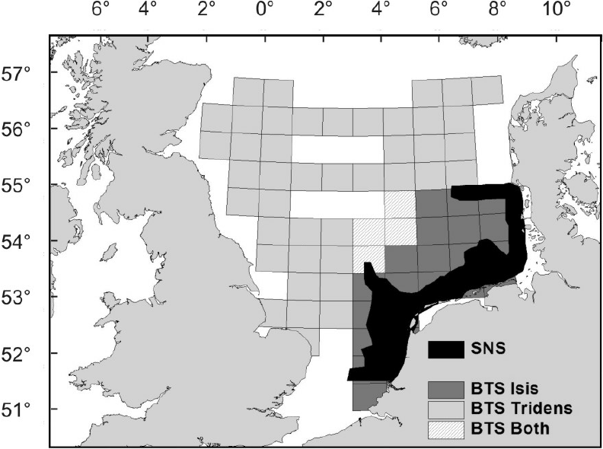](https://www.google.nl/url?sa=i&rct=j&q=&esrc=s&source=images&cd=&cad=rja&uact=8&ved=0ahUKEwih1-n6zrvVAhXCKVAKHTf4C6gQjRwIBw&url=https://www.researchgate.net/publication/29491887_Estimating_stock_parameters_from_trawl_cpue-at-age_series_using_year-class_curves?_sg%3DTF9Bzv7D10vucN24Pn2quY3VLUqPx7-4aIBDA9Xi266JgeIR-ZCvQD1YhhnPxVlNZoiwC8TP6PYPS_FpypbK3g&psig=AFQjCNEYJkjQOOsEZHezoEUzU468o983Cw&ust=1501868674021869)

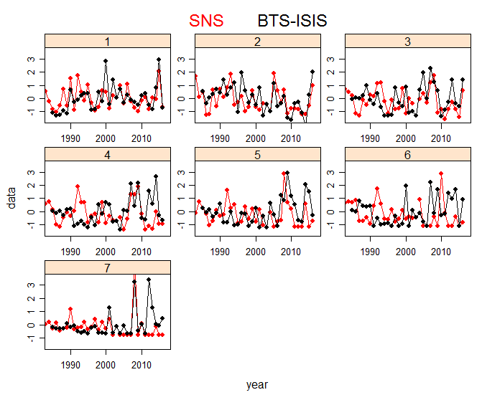

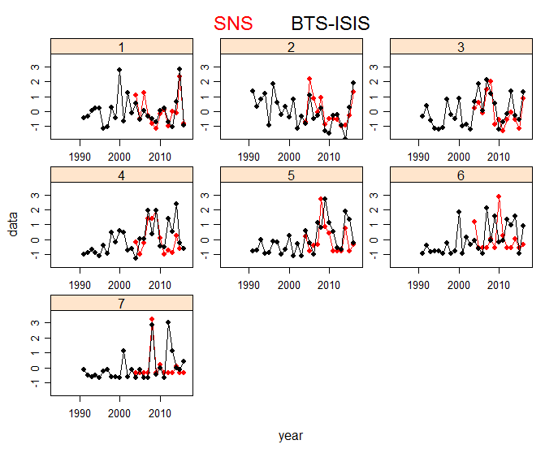

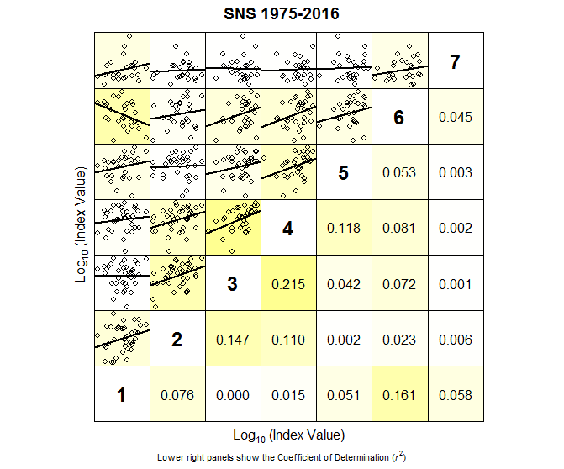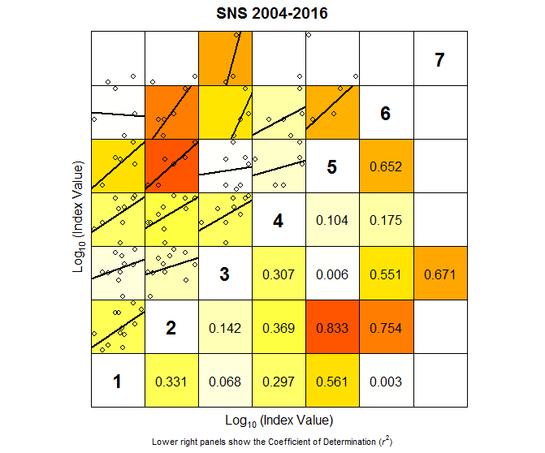

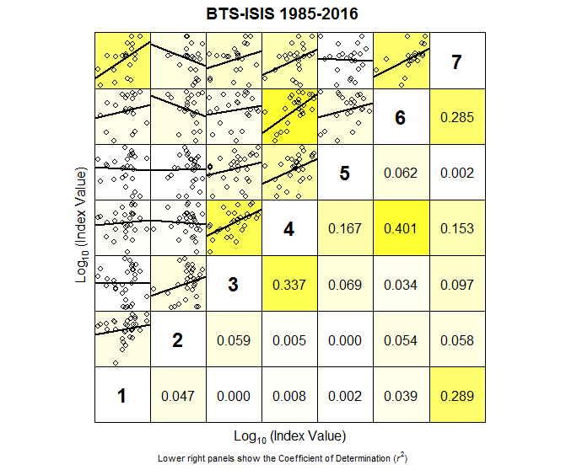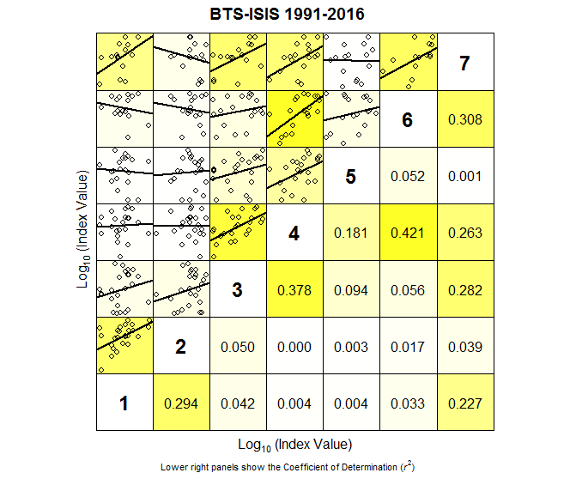

Internal consistency plots for the two age structured index series, for current time span, and for time span where age samples are available.

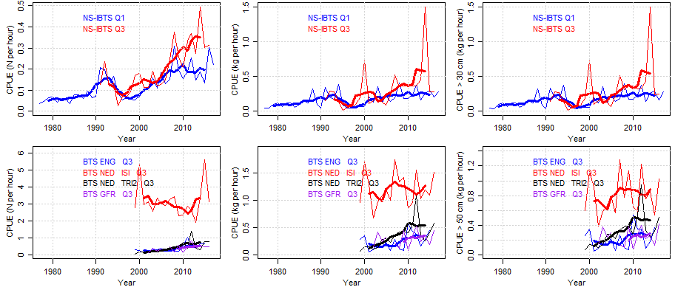

IBTS and BTS time series in n/hr, kg/hr and kg/hr for indvs >30 cm. Thins lines are annual estimates, bold lines are running means.